Wobble cushion – beginner exercises

Proprioceptive / Stability Exercise
Getting on the cushion:
- Encourage your dog to move towards the cushion (balance pad) by luring them with food
- Reward them with the treat as they touch the wobble cushion with their paw
- You may need to cover the cushion with a towel or dog blanket if they are worried about getting on it
- Keep encouraging, luring & rewarding correct behaviour until they willingly place both feet on; see pic (a).
- Practice this a few times until you dog is happily & confidently getting on the cushion
- Once in position, practice making them wait there for a few seconds before giving the reward.
- Now they are ready to start progressing

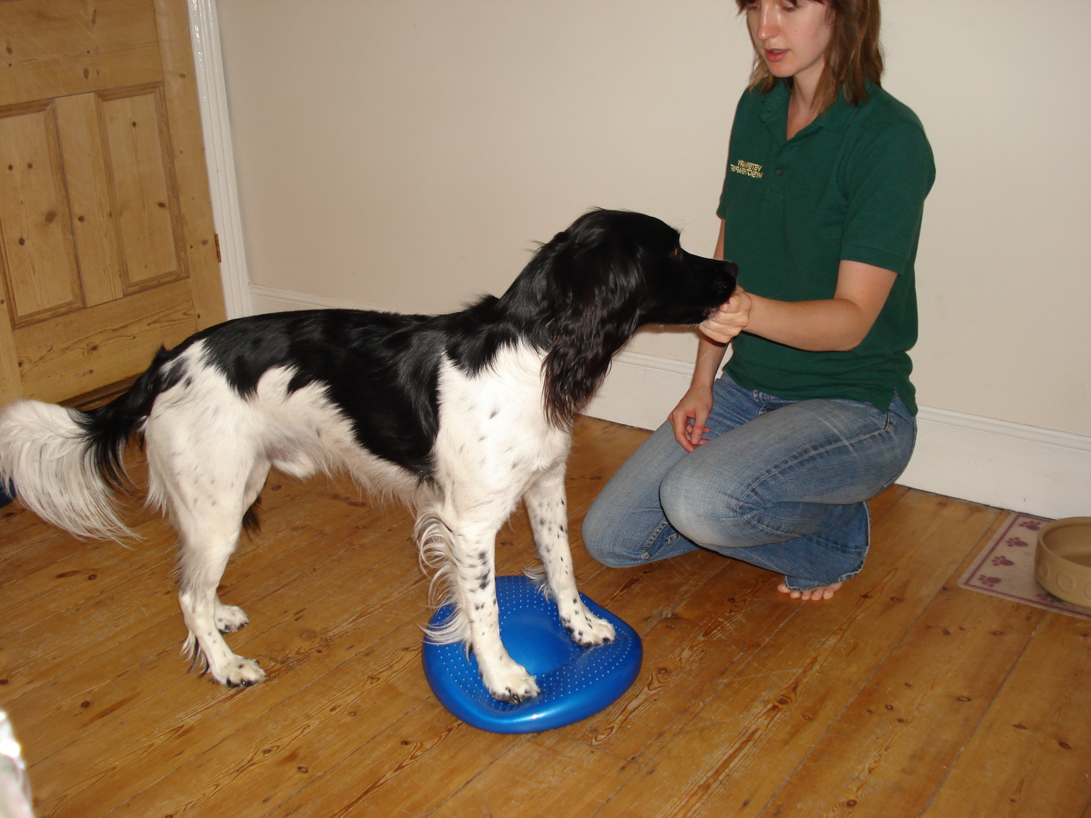
(a)

Exercises on the cushion

- i) Head Turns : these are very small quick movements side to side by luring with the food (remember to reward intermittently so they don’t get frustrated and get off the cushion)

Seconds: 3-5 Reps: 5 Sets: 1-2 No. Times per day 1-2

- ii) Rhythmic stabilisations. Apply gentle slow pressure to your dog’s pelvis, wait for your dog to resist you & then let go. Apply side to side +/- forward / back pressure. Your dog will recruit their postural stabilising muscles and improve core strength and balance.

Hold for 3-5 seconds Do 5-10 each side Sets 1- 2 No. / day: 1-2
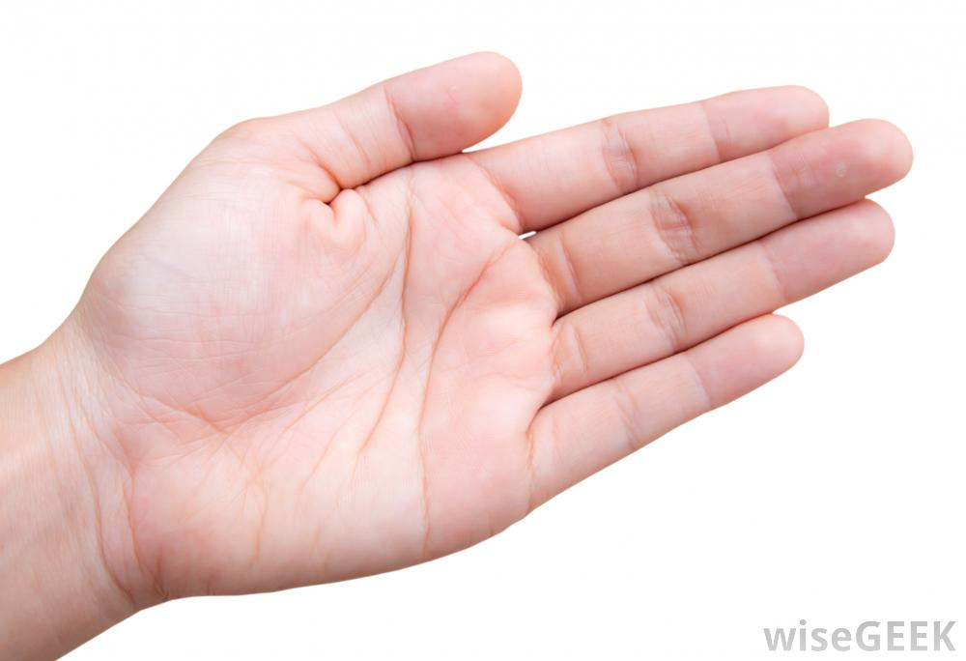

Large 60cm big “air stability cushions” can be purchased from www.officefitness.co.uk (Amazon also stock)
33-35 cm cushions are widely available on the internet.

